12/11/2019

Aayush Garg

Final Project – SYS660

Trade Study Analysis

Buying a house

Table of Content

Figures 2

Tables 2

1. Executive Summary 3

2. System Definition 4

a. Buying a house 4

b. Mission and CONOPS 4

c. Stakeholders 4

3. Major Uncertainties/Assumptions 5

4. Objectives 6

a. Fundamental Objective Hierarchy 6

b. Means Objective Network 6

5. Alternatives 7

a. Generating Alternatives 7

b. Description of Alternatives 8

6. Trade Study Analysis 12

a. Process 12

b. Criteria and Weights 12

c. Pair-wise comparison for determining weights 13

d. Scoring Descriptions 14

e. Evaluation 17

f. Sensitivity Analysis 18

g. Final Recommendation and Justification 19

7. Risk/Opportunity 20

a. Risk Situation / Risk Log 20

b. Risk Management 20

# Figures

Figure 1. Fundamental Objectives Hierarchy 6

Figure 2. Mean Objective Network 6

Figure 3. House 1 8

Figure 4. House 2 8

Figure 5. House 3 9

Figure 6. House 4 10

Figure 7. House 5 10

Figure 8. House 6 11

Figure 9. Area Utility Curve 14

Figure 10. HOA fee Utility Curve 15

Figure 11. Sun Numbe Utility Curve 16

# Tables

Table 1. Stakeholders 5

Table 2. Must-Haves 12

Table 3. Want Criteria 13

Table 4. Pairwise Comparison 13

Table 5. Area Scoring Scale 14

Table 6. HOA fee Scoring Scale 14

Table 7. Sun Number Scoring Scale 15

Table 8. Amenities Scoring Sale 16

Table 9. Looks Scoring Scale 16

Table 10. Trade study analysis 17

Table 11. Merit - Cost Ratio 18

Table 12. Before Performing Sensitivity Analysis 18

Table 13. After performing Sensitivity Analysis 19

Table 14. Risk Log 20

**1. Executive Summary**

My sister and her husband have been married for 2 years now. They have been living in a rented apartment in Secaucus, NJ. It is a 1-bedroom apartment with very limited storage. Its rent is $2600/month. And if they want to move to a 2-bedroom apartment in the same building the rent will go as high as $3500/month. Even after paying such high rent, they are not increasing their total asset value. In September of this year, my Brother-in-law’s parents visited them from India and stayed there for about 15 days. Because there is only 1 bedroom available, my sister and her husband had to sleep on a mattress in the living room for that duration. This is not an ideal situation. Even when I visited them, I mostly slept on the couch. They weren’t very happy about it. Also, my sister who likes to cook on a daily basis does not like the kitchen and wanted to make some changes in the structure of the kitchen but this is not acceptable to the society hence she wasn’t able to do any transformation to the kitchen.

After facing so many issues they realized that these problems can only be solved if they had their own house. And after a lot of discussion and after going through their financials they confirmed that they indeed should buy a house and set a budget on the house. The lease of their current apartment is till February 2020 and if they want to extend the lease, they must inform the society till January 14, 2020. So, they must make a choice till then. I performed a trade study, which is recorded in the following pages. It explains the process and the approach taken to make to a conclusion. I collaborated with my sister and her husband in order to find what they are looking for in the house.

**2. System Definition**

**a. Buying a house**

My sister and her husband are looking to buy a house in or close to Nutley, NJ where a few of their close friends live. With this they will start a new chapter in their life.

**b. Mission and CONOPS**

My sister and her husband are in search of buying their first home. They are currently living in a rented apartment in Secaucus, NJ. They also wanted to invest their money and buying a house would be good way to do so. They don’t have any kids and don’t plan to have any for the next few years. This means that its only two of them that will be living in the house for the most part. I live in Jersey City and tend to spend some weekends with them. They also have some cousins who come by occasionally and therefore they are looking to buy a 2-bedroom house. They are currently living in a one-bedroom apartment which makes it difficult for them to handle guest also causes shortage of space. A 2-bedroom house should make it easier for them to provide room for their guests.

They both work in New York City and must commute to work every week from Monday to Friday. Therefore, it is essential to have a feasible commute time, which they don’t want it to be more than 30 minutes. They have a Toyota Camry, which is a sedan and would be requiring a parking space for that, preferably a garage. They wash their cloths themselves and so they would be needing space for washer and dryer.

They plan to live in their new home for 3-4 years after which they plan to grow their family and then buying a new and bigger house. Therefore, they plan to buy a property which has some potential of giving a good return in future either by selling the house or renting it. They also plane to install solar panel in the near future.

**c. List of Stakeholders**

When buying a house many people gets associated either directly or indirectly. These stakeholders are depicted in the following table, Table 1, which shows the active and the passive stakeholders and a brief explanation on their interest.



Table 1- Stakeholders

**3. Major Uncertainties/Assumptions**

There are 4 major Uncertainties/Assumptions that are under consideration with respect to buying a house.

**Assumption 1**: All the area of the house will be utilized.

**Explanation:** Generally, when the area of a property increases the price also increases. So, it is under assumption that all the area that a house offers will be utilized and so this increased the weightage of area that originally intended.

**Assumption 2:** Maintenance of all the houses under consideration will be the same.

**Explanation:** The maintenance cost of each house will differ depending on the size, material used, age of the house, etc. But we have made an assumption that the maintenance cost will be same for all the houses because it won’t be conceivable to calculate the exact maintenance cost for all the houses.

**Uncertainty 1:** The Price of the houses.

**Explanation:** While buying a house the price can be negotiated and the final price be brought down. But while placing an offer if someone else also fights you for the same house the price of the house will go up. And so, I have taken the expected price in the trade study for all the houses.

**Uncertainty 2:** The selling Market.

**Explanation:** As it was notified earlier that my sister and her husband are buying the house as an investment also, it cannot be judged what the real estate market will be like in the time to come. Therefore, this is a major uncertainty that cannot be worked upon accurately.

**4. Objectives**

While determining the objectives, it is very crucial to differentiate between the fundamental objectives and the means objectives. By doing so we can understand the importance of the objectives and can also help in achieving other objectives.

**a. Fundamental Objectives Hierarchy:**

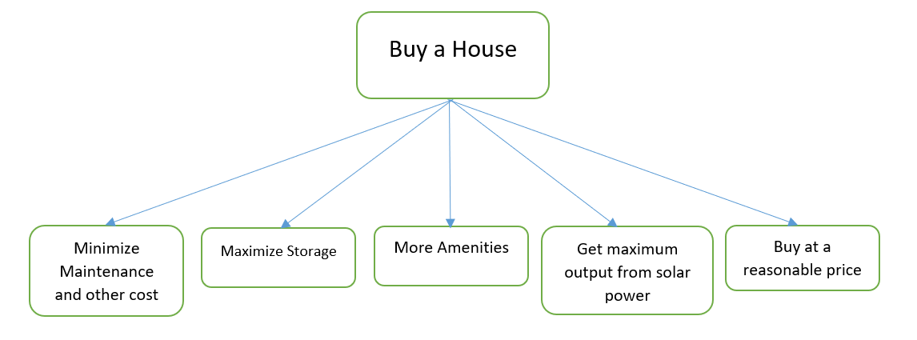The fundamental objective and supporting objectives are shown in Figure 1. This figure shows what are the important aspects that my sister and her husband keep in mind while making decisions for buying the house.

Figure1:**Fundamental Objectives Hierarchy**

**b. Means Objective Network:**

A means objective network helps us to achieve the fundamental objectives. Figure 2 below shows the means objective network for the decision model in this trade study. To find the mean objective we must follow two steps, first, move away from fundamental objectives: “How could you achieve this?” and second, move toward fundamental objectives: “How is that important?”

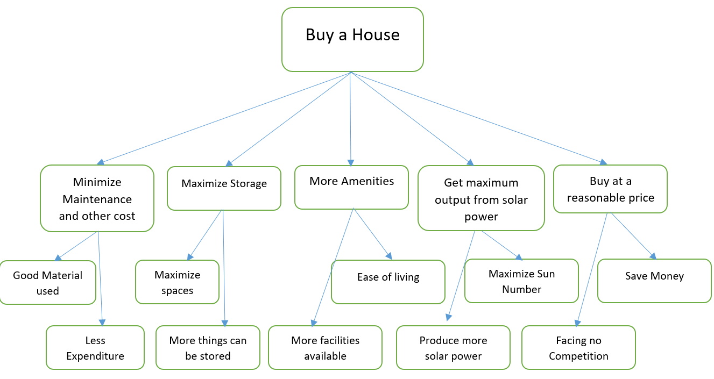

Figure 2- Mean Objective Network

**5. Alternatives**

**a. Generating Alternatives**

My sister and her husband have been living in a rented 1-bedroom apartment for two years and now they realized that they need more space for two reasons. Firstly, for storage purposes and secondly, to accommodate guests. Therefore, they decided to go with a 2-bedroom place with ample storage. But even then, there were many early decisions to be taken. For example, whether they should buy or rent, choosing between apartment, single family house, townhouse or condos. Then an important decision was the location. To decide on these options, they chose 3 ways 1) talk to friends and family and take their advice, 2) talk to an agent and 3) research online.

The first decision was whether to buy or rent. They opt to buy a place rather than renting mainly because the apartment they are living in has a high rent of $2600/month. Even then their asset value is not increasing. And if they buy a place, they could save on taxes and it does give a ‘Pride of Ownership’. Also, in future they could sell the place or put it on rent.

The next decision was choosing between an apartment, a single-family house or a townhouse. They decided to look for townhouse rather than apartment or single-family house. The reasons for not choosing apartment are the storage available will be less as compared to other options also there is less freedom like in making alterations. The reasons for not choosing a single-family house are that there is certain thing that the society takes care of like removing snow, taking the trash, maintenance of the lawn etc. also townhouse provides more a sense of security as compared to single-family house.

The next decision was very crucial, deciding the city/area to look for a house. After this decision they could start shortlisting the houses. As described earlier, my sister and her husband work in New York City and therefore they wanted the commute time to be less than 30 minutes. Their two friends who were living in the same building in which they currently are had moved to Nutley, NJ. Nutley has an approximated commute time of 20 minutes to New York City. And so, they decided to look for houses in Nutley and Clifton which lie alongside. After a lot of research and discussion they shortlisted 6 houses.

**b. Description of the alternatives:**

The 6 houses that are selected are described below:

**1. House 1:**

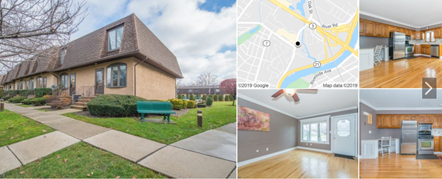

Figure 3- House 1

This corner house located at 24 River Road, Clifton, NJ is a 3-level townhouse with 2-bedroom, 2-full bath and one-half bath. It was built in 1981. The total area of this house is 1216 Sq. Ft. Level one provides a garage for parking o one car. This level also has the laundry area and the office room. Level 2 consists of kitchen, dining room, living room and a half bathroom. Level 3 has the master bedroom with an attached bathroom, 2nd bedroom and another full bath. Level 3 also consists of ample storage area. The community has homeowner’s association fee (HOA fee) of $300 per month. This consists of an outdoor swimming pool, Tennis court, a basketball court, Snow Removal, Maintenance-Exterior, Trash Collection and Water Fees. The solar potential, sun number is 91.59. The material used for the roof is Asphalt and for exterior Stucco is used. The expected price of the house is $305,000.

**2. House 2:**

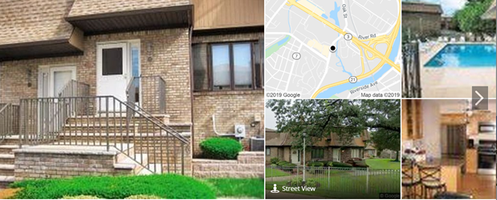

Figure 4- House 2

This house located at 70 River Road, Clifton, NJ is a 3-level townhouse with 2-bedroom, 2-full bath and one-half bath. It was built in 1985. The total area of this house is 1500 Sq. Ft. Level one provides a garage for parking of two cars. This level also has the laundry area. Level 2 consists of kitchen, dining room, living room and a half bathroom. Level 3 has the master bedroom with an attached bathroom, 2nd bedroom, another full bath and an office area. Level 3 also consists of ample storage area including a walk-in closet in the master bedroom. The community has a HOA fee of $372 per month. This consists of an outdoor swimming pool, Snow Removal, Maintenance-Exterior, Trash Collection and Water Fees. The community is also fenced and has a gated entry. The solar potential, sun number is 90.79. The material used for the roof is Asphalt and for exterior Brick, Wood is used. The expected price of the house is $356,170.

**3. House 3:**

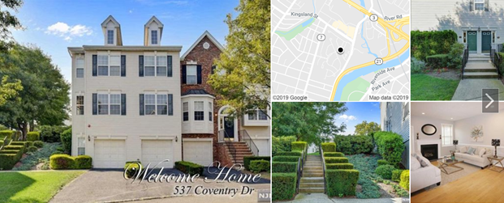

Figure 5- House 3

This house located at 537 Coventry Dr, Nutley, NJ is a 3-level townhouse in the community “Cambridge Heights”. The house has 2-bedroom, 2-full bath and one-half bath. It was built in 2001. The total area of this house is 1876 Sq. Ft. This house was recently renovated. Level one provides a garage for parking of two cars. This level also has the laundry area and a backyard. Level 2 consists of kitchen, dining room, living room and a half bathroom. Level 3 has the master bedroom with an attached bathroom, 2nd bedroom, another full bath and an office area. Level 3 also consists of ample storage area including a walk-in closet in the master bedroom. The community has a HOA fee of $360 per month. This consists of an outdoor Tennis, Fitness Center, Snow Removal, Maintenance-Exterior, Trash Collection and Water Fees. The community is also fenced and has a gated entry. The solar potential, sun number is 76.39. The material used for the roof is Asphalt and for exterior Vinyl is used. The expected price of the house is $395,000.

**4. House 4:**

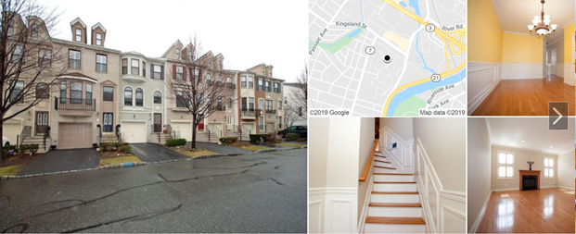

Figure 6- House 4

This house located at 423 Manchester Dr, Nutley, NJ is a 3-level townhouse in the community “Cambridge Heights”. The house has 2-bedroom, 2-full bath and one-half bath. It was built in 2001. The total area of this house is 1986 Sq. Ft. Level one provides a garage for parking of one car. This level also has a backyard, a barbecue area and a family room. Level 2 consists of kitchen, dining room, living room and a half bathroom. The living room consists of a gas fireplace and built-in speakers. Level 3 has the master bedroom with an attached bathroom which has a jacuzzi, a second bedroom with attached bathroom. Master bedroom has a walk-in closet. Level 3 also has laundry room. The community has a HOA fee of $360 per month. This consists of an outdoor Tennis, Fitness Center, Snow Removal, Maintenance-Exterior, Trash Collection and Water Fees. The community is also fenced and has a gated entry. The solar potential, sun number is 74.79. The material used for the roof is Asphalt and for exterior Vinyl is used. The expected price of the house is $444,906.

**5. House 5:**

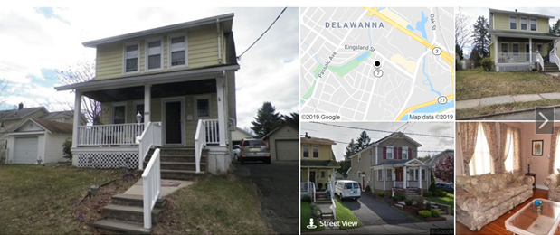

Figure 7- House 5

This house is located at 109 Pershing Ave, Nutley, NJ is a 2-level single-family house. The house has 3-bedroom and 2-full bath. It was built in 1940. The total area of this house is 1308 Sq. Ft. There is a garage for parking of one car. This house also has a large backyard. Level one consists of kitchen, dining room, living room, a bedroom, a bathroom and a laundry room. Level 2 has the master bedroom, 2nd bedroom and a full bathroom. Level 2 also consists of ample storage area including a walk-in closet in the master bedroom. The solar potential, sun number is 91.59. The material used for the roof is Asphalt and for exterior Stucco is used. The expected price of the house is $375,031.

**6. House 6:**

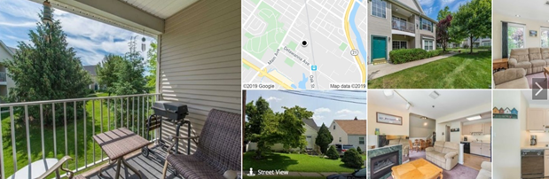

Figure 8- House 6

This house located at 240 Cambridge Ct, Clifton, NJ is a 2-level townhouse in the community “Cambridge Heights”. The house has 2-bedroom and 2-full bath. It was built in 1996. The total area of this house is 1287 Sq. Ft. Level one consists of kitchen, dining room, living room, master bedroom with attached bathroom, second bedroom, a bathroom and a laundry room. Level 2 is an open area perfect for an office, recreation area. The community has a HOA fee of $285 per month. This consists of an outdoor Pool, Fitness Center, Snow Removal, Maintenance-Exterior, Trash Collection and Water Fees. This house does not have a garage parking, but parking is available outdoors. The community is also fenced and has a gated entry. The solar potential, sun number is 80.39. The material used for the roof is Asphalt and for exterior Vinyl is used. The expected price of the house is $335,573.

**6. Trade Study Analysis**

1. **Process description**

In order to make a recommendation from the above described alternatives, we perform a trade study analysis on these alternatives. Depending upon the objective that were described in section 4-a, these alternatives will be getting a total score. Also, these objectives will be given weightage depending upon their important relative to one-another. The subsequent sections will describe how the analysis was performed from creating the criteria to finally conducting a sensitivity analysis to produce an outcome.

1. **Criteria (Must Have and/or want criteria).**

Depending on what my sister and her husband are looking in a house I defined nine criteria. Four of them are must have criteria and the other five are wants criteria. After taking to people and a long discussion, they decided that the following four criteria are essential, described in Table 2.



Table 2 – Must-Haves

Along with the 4 must haves we also have 5 want criteria. These are shown in the below in Table 3.



Table 3- Want criteria

1. **Pair-wise comparison for determining weights**

A pairwise comparison was completed in order to determine the weighting associated with the chosen criteria. In Table 4, the ranking of each criteria against the other is shown. For the comparison 1 depicts that both the criteria are equally important. I have kept the limit to 5 which means extreme importance of one criterion over the other. And as the score increases from 1 to 5 the importance of one criterion over the other increases. The resulting weight of each criteria is shown in the final column.



Table 4 - Pairwise Comparison

From the above table it can be judged that area has the highest weightage among all the want criteria of 36.44%. The least importance is of sun number of 8.37%, which was expected. The consistency ratio for the above comparison was 0.03 which was less than 0.10 and hence this result can be further used in our analysis.

1. **Scoring Scale and Utility tables or curves for each criterion**

For this Trade Study Analysis, I have used a scale of 1 to 5, 1 being the lowest and 5 being the highest, for each alternative in each of the criteria.

The area of the house, which has the highest weightage of 36.44%, is the most important criteria of all. It will affect the storage available, the sizes of room, etc. It has a scale of 1 to 5, describe in the table 5.



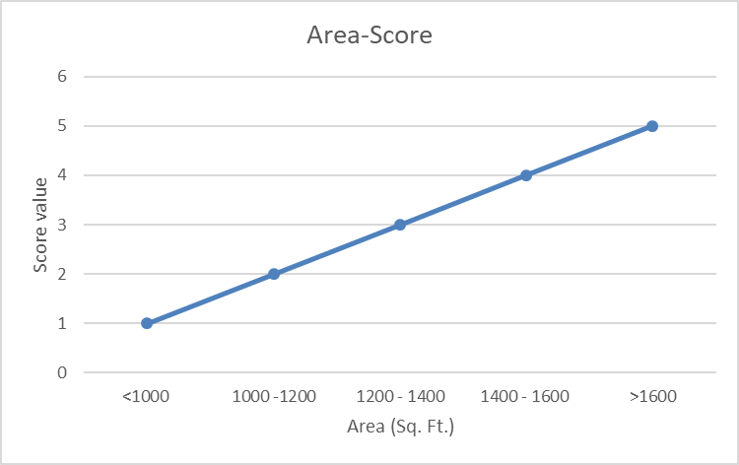 Table 5- Area and Scoring scale

Figure 9- Area utility

The Homeowners Association fees which is to be paid every month and therefore must be minimized. This fee depends upon the facilities that are provided in the society and it also depends on the total area of the house. The more the area the more the fee. The Table 6 below describes the HOA fee scoring.



Table 6- HOA fee scoring scale

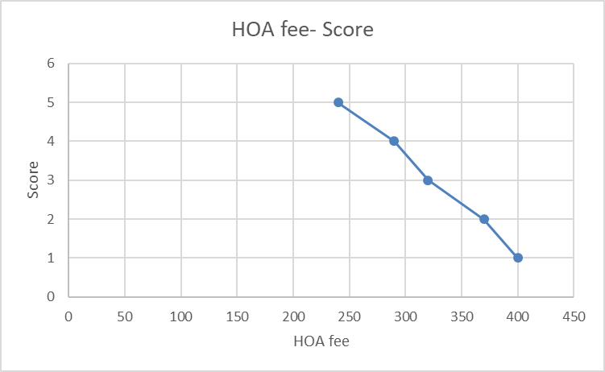

Figure 10- HOA fee utility

A Sun Number score is a rating from 1-100 that shows the potential for solar capabilities of the house. The closer the score is to 100, the better suited your home is to have solar technology installed. It takes into account the area of the roof that can support solar panels, the direction the roof is facing, the pitch, or slope, of the roof, how much direct sunlight the roof receives, average weather conditions, local cost of electricity and local cost of solar installation. The scoring for is described in the Table 7, below.



Table 7- Sun Number scoring scaling

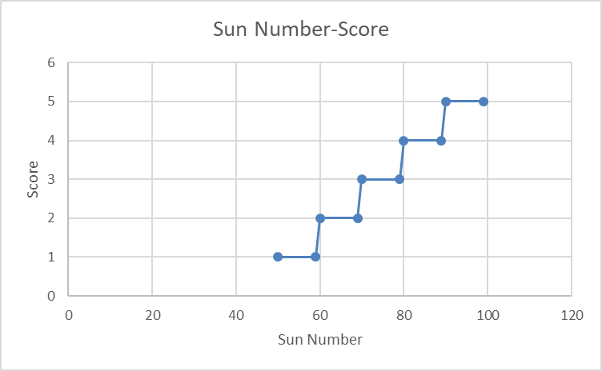

Figure 11-Sun Number utility

While living in a society, it is very important to consider the facilities available within the society. These may include Tennis, Outdoor pool, fitness center which may include gym, fence around the society, a gated entry in the society for more security and garage for parking a car indoors. The Table 8 shows the amenities scoring scale.



Table 8- Amenities Scoring scale

The first impression always lasts long and therefore the exterior of the house has its importance. The material used will not only affect the looks but can also affect the future maintenance of the house. For example, houses build with bricks generally have very low maintenance in future and therefore have a high score of 5. And similarly scoring has been done and shown below in Table 9.



Table 9- Look Scoring scale

1. **Evaluation**

All the information collected has been put into a tabular form in the following table, Table 10. This information will be further used to calculate the total score of all the alternatives and performing the trade study analysis to evaluate the best alternative. The are four must have criteria and five want criteria. If an alternative clears all the must have then only want criteria are scored. There are only four alternative that cleared the must have criteria. House 4 and house 5 did not clear the must criteria and therefore they aren’t scored in want criteria. The scoring for the other houses is shown in the Table 11.

For calculating the total score, value for each alternative is determined against each criterion. The weightage of each criterion is also determined. Score is calculated by multiplying the value and the weight. These scores are than summed up to give a total score for each alternative.

House 3 has the highest score of 4.35, while house 2 lags a little behind with a score of 4.19. But, house 1 and house 6 can be rejected for further analysis as they have relatively low total score of 3.31 and 3.78, respectively

Table 10- Trade study

Merit to cost ratio has been evaluated and shown below in the Table 11. House 2 has the merit-cost ratio of 1.064 followed by House 3 with a ratio of 0.995, which is very close. Whereas, House 1 and House 6 can be eliminated from further evaluation as they have the least merit-cost ratio of 0.980 and 0.957, respectively.

 Table 11- Merit to cost Ratio

1. **Sensitivity Analysis**

After performing the trade study analysis and looking at the merit-cost ratio, a clear choice between House 2 and House 3 can not be made. House 2 has a higher merit-cost ratio, but House 3 has a higher score in Trade study. Therefore, we are performing Sensitivity Analysis (One-way).

One-way Sensitivity Analysis is to vary the weight of one criteria by a small amount to check the changes in the result. For our analysis we will be increasing the weight of one criteria by 10% and reducing the weight of another criteria by the same amount, so as to keep the total of the weight 1.00. Frist, we have to choose one criteria of the five. Table 12 shows the data before performing Sensitivity Analysis.



Table 12- Before performing Sensitivity Analysis

**Area:** This criterion has the highest weightage and therefore has the most importance. But increasing the weight will not have any change in the evaluation. It so because House 3 has a higher score in the area criteria. But the weight can be reduced.

**HOA fee:** Similar to Area, increasing the weight of this criteria will not cause any change in evaluation as House 3 has a higher score in the area criteria but it can be reduced.

**Sun Number:** Since, the score of House 2 is higher the weight of this criteria the weight of this criteria can be increased and should not be reduced.

**Amenities:** As the score of both the houses is same, i.e. 5, changing the weight of this criteria will not have any effect on the evaluation in any manner.

**Looks:** Since, the score of House 2 is higher, the weight of this criteria can be increased and should not be reduced.

Therefore, we choose to increase the weightage of Looks by 10%, i.e. 0.019, and to reduce we have two option Area and HOA fee. But we will reduce HOA fee as it has a lower weight. Table 13 shows the data after performing Sensitivity Analysis. But even after the sensitivity analysis, House 3 has a higher total score. This means that the original scores are insensitive to a small change in the weight of the criteria.



Table 13- After performing Sensitivity Analysis

1. **Final Recommendation and Justification**

Even after doing all the research, collecting data, making assumptions, taking uncertainties into account, performing the analysis, there are certain things that can not be put into graphs and tables. But after performing the analysis above I am sure that my work will be supportive to make decision by sister and her husband. And I have come to a conclusion of this report. I would recommend to my sister and her husband that they should buy House 3, located at 537 Coventry Dr, Nutley, NJ.

Alternative 3 or House 3 has the highest total score among all the alternatives. With the second highest merit-cost ratio, it is the best option to buy. Even though the House 2 performed very well overall it only lagged in the Area criteria. I would also like to point that House 3 has a price tag of $395,000 while House 2 has a price tag of $356,170 and if while making the final decision they decide to cut their budget I would recommend House 2.

**7. Risk/Opportunity**

**a. Risk situation**

To settle on a decent alternative, it is equally critical to know about the possible risks or opportunity related to that alternative. A Trade study analysis can provide us with the best possible choice but taking the risks into account is very important. It is also very crucial to determining the mitigation plans for them.

The following table, Table 14, shows the possible risks associated, their consequence, ther probability(P), Impact (I), The risk value (P x I) and the mitigation plans.

The value of Probability and Impact varies from 1 to 5. 1 being the low probability/Impact and 5 being high probability/Impact. The risk value is the product of probability and impact. The higher the risk value, the sooner that risk should be dealt with.

Risk 1 has the highest risk value and should be dealt with as soon as possible. While other risks have a very low risk value which means that they are not worrisome.



Table 14- Risk log

1. **Risk Management**

As all the risks, either mentioned in Table 14 or not, occurs the consequence will be upon the primary residence i.e. my sister and her husband. Therefore, it is their responsibility that they manage all the risks. They should identify the risks and determine the ways in which they can avoid them or determine some mitigation strategies.

The risk management can be started even before they make the decision. They can talk to people living around the house under consideration. They can ask these people about the society and take their review on the facilities available. They should get a thorough inspection of the house in which they can find any damages in the house. Also, knowing the past valuation of the house is important. Buying a house is a major decision and involves a large amount of capital, so, it makes risk management very crucial.